Elements of
Project Management
Workbook
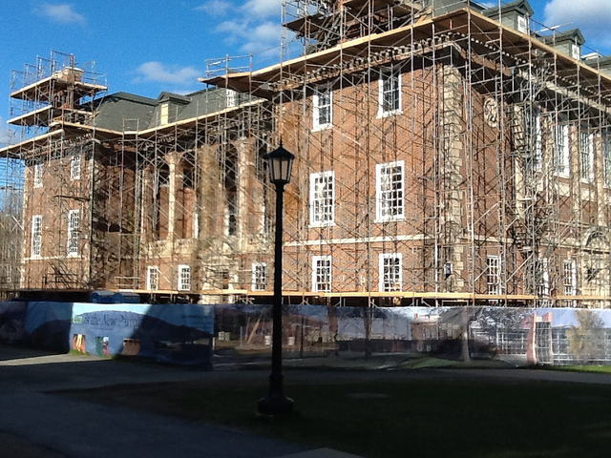

Mission Statement
Mission statements should be:
- Brief: You could say it in the course of a ride up an elevator with someone.
- Concrete: The project is described in terms that are immediately graspable by your audience.
- Impactful: The benefits of the project are vividly described.
and should answer the following questions:
- What? What are the project’s objectives?
- Why? Why are we doing this?
- How? How will we achieve the project’s objectives?
In the space below, write a mission statement for your project:

SMART Goals
Goals are the concrete achievements that will fulfill the project’s mission. Ideally, goals are:
- Specific
- Measureable
- Attainable
- Relevant
- Time Bound
In the space below, write one of the goals of your project.

Constraints
Constraints are the known limitations on the project, especially in terms of
  - Time
  - Cost
  - Scope/Quality
In the space below, describe the constraints for your project.

Time
Cost
Quality

Project Management
Risk Analysis Worksheet
Choose a significant risk for your project and answer the questions about them.
Risk:
Where is this risk on the likelihood/impact grid?
 | Impact
Likelihood |  | Insignificant | Minor | Moderate | Major | Severe
 | Almost Certain
 | Likely
 | Possible
 | Unlikely
 | Rare

What specifically would be the impact of the risk on the project if it were to occur?
Who needs to know about this risk?
What can you do to reduce the risk that the event will happen?
What can you do to reduce the impact of the risk on the project, should it occur?

Project Management
RACI Chart
Project Phases | Stakeholders
R= Responsible; A=Accountable; C=Consulted; I=Informed

Stakeholder Analysis
Project:
Stakeholder:
Peripheral
Key
Core
Using this bulls-eye, mark how critical this stakeholder is to your project:

What are this stakeholder’s hopes for the project?

What are their fears for the project?

What strengths, qualities, or resources can this stakeholder bring to your project?

What limitations of this stakeholder most concern you?

How much political power or influence does this stakeholder have?
1  Minimal | 2 | 3 | 4 | 5  Middling | 6 | 7 | 8 | 9 | 10  High

How opposed or in favor of the project is this stakeholder?
1  Strongly Opposed | 2 | 3 | 4 | 5  Neutral | 6 | 7 | 8 | 9 | 10  Strongly In Favor

Based on what you know of this stakeholder, what strategies could you use to best enlist them for your project? How will you communicate with them? How often?
Project Management
Milestones
To develop milestones for your project, visualize the successful completion of the goal. What will need to happen for that goal to be achieved? Keep working backwards until you get to the milestone you can work on now.

Goal
Work downward until you reach the milestone for the project you are working on now.

Project Management
Work Breakdown Structure
In the space below, sketch out a draft work breakdown structure for your project.

Project Management
Meeting Notes Summary
MEETING NAME
Date:
Attending:
Absent:

Topic:
Discussion summary | Action Steps | Responsible | Due Date

16 Reasons They’re Not Doing What They’re Supposed to Do
Adapted from Coaching for Improved Work Performance by Ferdinand Fournies
Could this be
an issue?
 | Yes | No | Don’t Know
- They don’t know what they’re supposed to do.
- They don’t know how to do it.
- They don’t know why they should do it.
- They think they are doing it, but they are not.
- There are obstacles beyond their control.
- They think it will not work.
- They think their way is better.
- They think something is more important.
- There is no positive consequence to them for doing it.
- There is a negative consequence to them for doing it.
- There is a positive consequence to them for not doing it.
- There is no negative consequence to them for not doing it.
- Personal limits (capacity)
- Personal problems
- Fear (they anticipate future negative consequences for doing it)
- No one could do it.

Project Management
Accountability Case Study
True story from Kevin’s career, told as a submission to an advice column:

I’m the project manager on a project to pursue the next level of the Green Office Certification. Many of the action items must be completed by the office administrator, who does not report to me and reports to a different manager from me. I perceive her as having a pattern of promising more than she delivers. At a team meeting, she agreed to accomplish the items in her functional area and understood our deadline. I have asked her if she needs help or assistance to contact me. We are scheduled to do a presentation at the next staff meeting announcing we’ve completed the project and getting sign off from all staff (a requirement for the certificate). The presentation is already on the agenda and has been distributed to staff. I haven’t heard from her and I haven’t seen any sign of progress. The staff meeting is looming next week, hardly enough time to complete all of the action items. I’m worried we won’t be ready. What should I do?

